Icons (We can Pick Different/colorful ones)

<http://www.flaticon.com>

Car Icons

<http://www.flaticon.com/packs/car-parts-4>

How I created Buttons with Icon/Vector

<https://www.youtube.com/watch?v=cOeK32o8eB4>

Swipe to Start New Activity

<https://www.youtube.com/watch?v=Q5Ndr944U2o>

Screens

Login, Create Account, Challenges, Trophies, Gallery

<https://developers.google.com/android/guides/setup>

Adding Achievements (unlocking)

<https://developers.google.com/games/services/android/achievements>

Leaderboards

<https://developers.google.com/games/services/common/concepts/leaderboards>

<https://developers.google.com/games/services/android/leaderboards>

Progress Bars for Challenges (? Is it possible to use)

<https://developer.android.com/reference/android/widget/ProgressBar.html>

Sample Pallettes

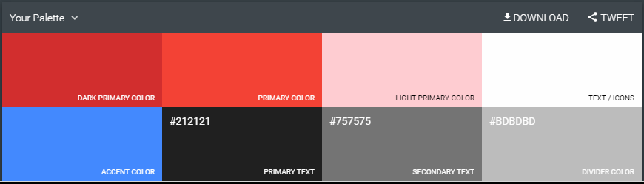

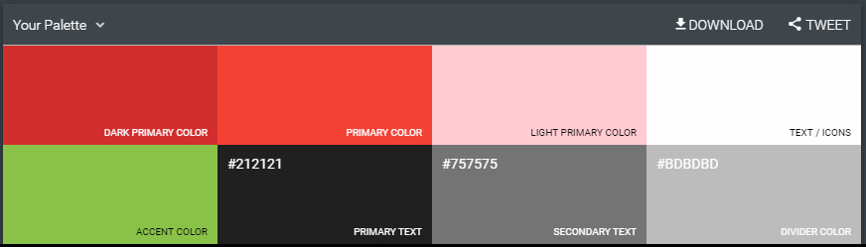

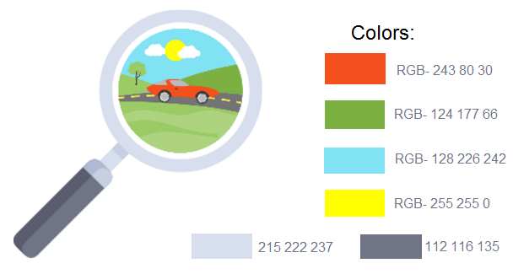

Color Pickers

<https://color.adobe.com/create/color-wheel/>

<https://www.materialpalette.com/red/light-green>

Design

<https://material.io/guidelines/components/bottom-navigation.html#>

Point System

1 car capture (picture) = 1 point

Trophies

25 car captures = bronze trophy

50 car captures = silver trophy

100 car captures = gold trophy

Achievements (Challenges)

Colors

* 10 Red cars
* 10 White cars
* 10 Black cars
* 10 Blue cars

Car Types

* 10 sports cars
* 10 classic cars
* 10 exotic cars

Implementing Gallery

http://blog.iamsuleiman.com/image-gallery-app-android-studio-1-4-glide/